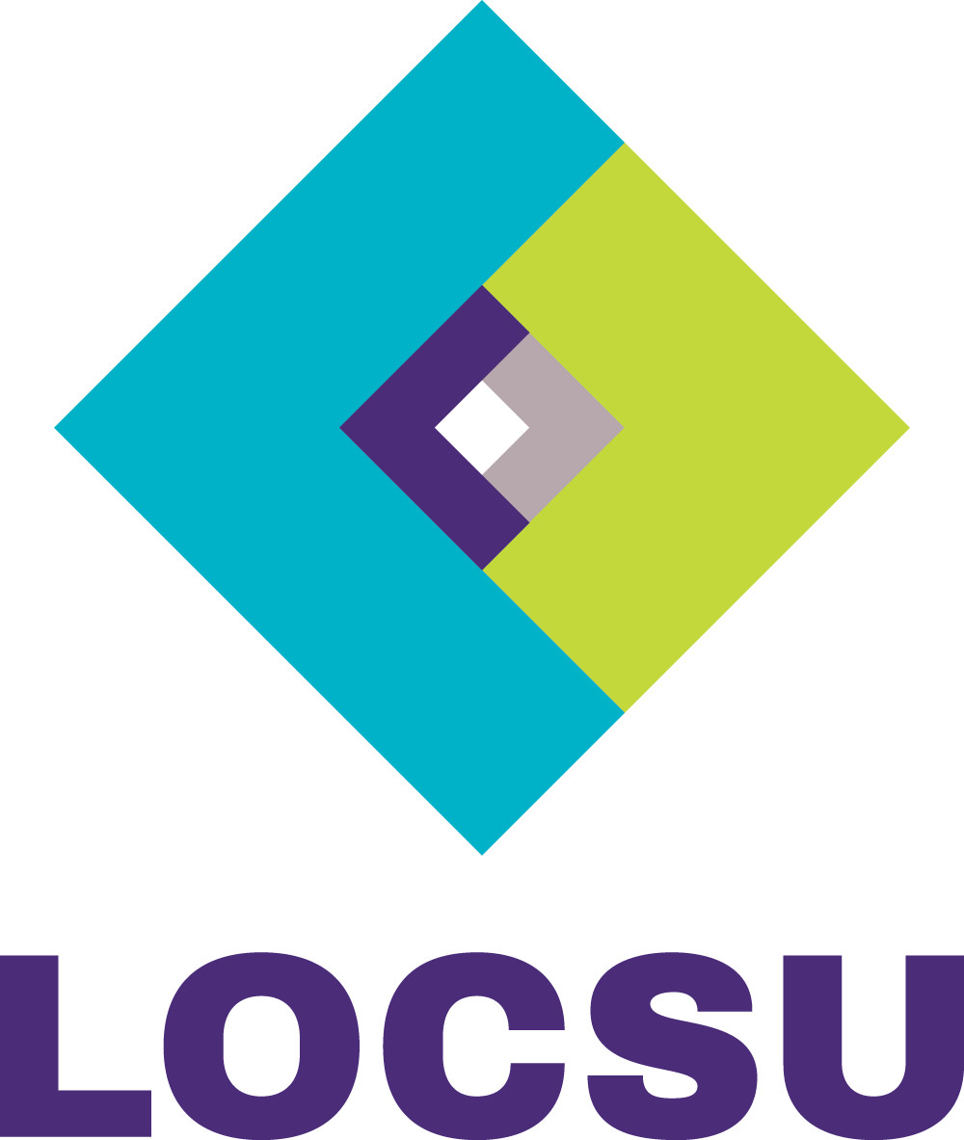

Local Optical Committee Support Unit (LOCSU)
LOC Levy Payment Form

Please complete form each and every time payment is made to LOCSU. The levy is 0.5%

Date
LOC Name
LOC Reference
(Optional – for your use)
Payment amount | £
Covering month(s)
(Please specify month/s and year/s)
Payment method
(e.g. BACS, cheque, SO, DD from CCG)
Your Name
Your Officer Position
Telephone Number
Email address

Payment details

By BACS: HSBC, 28 Borough High Street, London, SE1 1YB
Account name: LOC Central Support Unit
Sort code: 40-06-21
Account: 91746405

Please return this form to:

By email info@locsu.co.uk
Tel: 020 7549 2051

