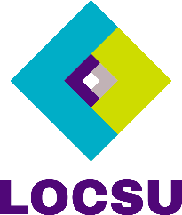
[insert LOC logo here]

Press release: 23 September 2024
FOR IMMEDIATE RELEASE

National Eye Health Week 2024 (23 – 29 September)
Organisers of National Eye Health Week (NEHW) are calling on everyone in optics to get involved and help spread the word on eye health in a bid to prevent avoidable sight loss for future generations.
During seven days of intensive activity, the Week will share essential eye care advice with millions of Brits helping them enjoy better eye health and safeguard their long-term vision.
David Cartwright, chair of Eye Health UK, the charity responsible for running the week said: “NEHW is a key calendar moment for promoting optics and helping people take better care of their eyes. This year’s campaign feels particularly timely as the new government commits to reduce waiting times and focus on prevention.
“During the week we’ll demonstrate how primary eye care professionals can, and do, play an important role in improving public health and helping us all well live well for longer.”
Janice Foster, Chief Executive at LOCSU, said: “Given the shocking statistic that 77% of people living in the UK regularly suffer bouts of poor eye health and that 50% of sight loss is avoidable, NEHW is an incredibly important week to promote healthy lifestyle choices and raise awareness of the importance of eye health.
“Primary eye care professionals play an integral role in supporting the public to look after their health. LOCSU always encourage LOCs to get involved with NEHW – it’s the perfect opportunity to promote the great work undertaken by passionate professionals to make a difference to local people.”
LOCs text to be inserted here.
Anyone interested in getting involved with National Eye Health Week can read more here: www.visionmatters.org.uk.

Notes to Editors:
Insert notes to editors.
LOC information:
Insert information about your LOC.
Press contact:
Insert press contact name, telephone number and email address.

