Extended Primary Eye Care Services
  - Eye Care Pathway
for People
with Learning Disabilities
Service Delivery Proposal
September 2020
Version 2.3

Contents

1. Introduction 3
2. Rationale 3
3. Definition of learning disability 4
4. Accreditation and training 4
5. Promotion 5
6. Contractual Model 6
7. Delivery of the Managed Service 6
7.1. Scope of the Managed Service 6
7.2. IT Platform 7
7.3. Records 7
8. Clinical Governance 7
8.1 Equipment 8
8.2. Assessment 8
8.3 Clinical Reporting 9
8.4 Policies and Procedures 9
8.5. Service Evaluation and Audit 9
9. Fees 11
10. Implementation 11
Appendix 1 – Optical practices 12
Appendix 3 – Governance: Quality in Optometry 14
Appendix 4 - Equipment 15

Introduction
In this proposal, [Primary Eye Care Company] sets out its high-level approach to the delivery of an enhanced primary eye care service for people with learning disabilities in [Name] CCG. This will be undertaken by an accredited practitioner within suitably equipped premises or where clinically indicated as a domiciliary service. The provider will manage the patient appropriately and safely and in accordance with their needs.
The intention is to provide a service that enables a degree of preparation, additional time and adapted communication and participation that many people with learning disabilities need to successfully access eye care and vision correction services. Management will be maintained within the primary care setting for as many people as possible, thus avoiding unnecessary referrals to hospital services. Where referral to secondary care is required, it will be to a suitable specialist, identified and consulted at commencement of the service, with appropriate urgency.
By improving access for this population to regular and routine eye care, there is also the potential to prevent loss of sight, help people make the best use of the vision they have and for carers and supporters to understand what the person can see. This in turn should improve outcomes and independence for people with learning disabilities, with the benefits seen across the local health and social care system.

Rationale
Approximately 1.2 million people in England have a learning disability and face significant health inequalities compared with the rest of the population. Despite experiencing greater ill health, people with a learning disability often experience poorer access to healthcare. The goal of the NHS Long Term Plan is to ensure that people with learning disabilities live longer, healthier and happier lives, and ensure NHS services and commissioners take a more concerted and systematic approach to reducing health inequalities and addressing unwarranted variation in care.
People with learning disabilities are known to be ten times more likely to have serious sight problems than the general population, and less likely to receive timely and appropriate eye care such as sight tests and glasses. Serious sight problems, such as significant refractive error or cataract, can also manifest at a younger age. Under reporting of eye and sight problems can occur due to difficulties in people with learning disabilities communicating visual or ocular problems, or signs or symptoms being overlooked or attributed to the person’s learning disability (known as ‘diagnostic overshadowing’).
Accessing sight tests is often a problem for people with learning disabilities, with many reporting they have not had a recent test . There may be a reluctance to attend a practice through fear of the process, believing that you have to be able to read or speak to have a sight test or will be rushed through the process without adequate time for preparation and suitable adjustments.
While there are legal obligations for eye care services to make reasonable adjustments for people with learning disabilities, it is recognised that for people with more moderate to severe learning disabilities in particular, a specialist care pathway is needed to allow people with learning disabilities to access services and receive equality of care in the community. This would complement the national commitment to introduce targeted eye, dental and hearing checks into England’s special schools in the NHS Long Term Plan. For more information on eye health prevalence, inequalities and practical support for people with learning disabilities, see Public Health England, Eye Care and People with Learning Disabilities, 2020.

Definition of Learning Disability
“A learning disability is a reduced intellectual ability and difficulty with everyday activities - for example household tasks, socialising or managing money - which affects someone for their whole life. People with a learning disability tend to take longer to learn and may need support to develop new skills, understand complex information and interact with other people. The level of support someone needs depends on individual factors, including the severity of their learning disability.” (Source: Mencap).
This service is designed for people with learning disabilities, but the principles can be applied to a broader population if need is identified locally. For example, people with autism who do not have a learning disability, and people with neurological and mental health conditions, such as dementia.

Accreditation and Training
Standards of conduct and practice for optometrists and dispensing opticians set out expectations in terms of communication, consent and adjustments for those with disabilities. In the future all those working in health and social care will be expected to have undertaken some mandatory training in learning disability and autism awareness, a scheme which is due to be introduced in 2021 . The intention is that this will also include front facing staff in health environments (e.g. receptionists) as well as clinical teams, taking a tiered approach to the level of training needed.
Many of the skills required for service delivery are core competency for optometrists and dispensing opticians, however it is recognised that additional skills and knowledge will be needed and a training and accreditation package is provided by LOCSU and Wales Optometric Postgraduate Education Centre (WOPEC) that practitioners should successfully complete before offering the service.
All practitioners will be required to undertake CET/CPD that is relevant to the service.

Promotion
While practitioners will be expected to use material adapted for those with learning disabilities and their carers and supporters (as highlighted in the clinical pathway), the wider promotion of the service by all stakeholders (including commissioners), on an ongoing basis, is crucial. Commissioning of ‘promotion’ activities, both at introduction and once the service is operating will be needed. Local referral pathways into the service e.g. via the annual health check (AHC), and engagement with local advocacy groups to promote uptake of the service should be defined when establishing the service.

People with learning disabilities are a ‘hard to reach’ group and part of the reason they are known to suffer health inequalities is because health promotion information is not accessible to them. The highest level of sight problems experienced by people with learning disabilities is amongst those with profound and multiple needs, and many people will be living in residential settings or with their families. Many people may not have access to the internet or email, so a range of promotional tools will be needed.
A list of participating practices who are part of the pathway is the first step in promotion. Wider engagement and support will be gained through learning disability leads within the local health and care system to promote the existence of the pathway to self-advocacy groups, family carers, learning disability nursing teams, social care providers and more.
Within health, key stakeholders are also GPs. They should be advised to signpost people with learning disabilities to the service as part of their annual health check (see also DATA below). Hospital eye care services should be aware there is a service that their patients with learning disabilities can use and into which they can be discharged when appropriate.
Commissioning and funding self-advocates to support the promotion of the service would be good practice. Local self-advocacy groups should be sought out, and the charity SeeAbility with its network of Eye Care Champions can advise on how best to promote the service. They can be contacted on 01372 755000 or via eyecare@seeability.org.
A local multi-disciplinary team in the Hospital Eye Service, a regional centre of excellence or another appropriate secondary care service will be identified locally when the service is established. This team will be consulted during establishment of the service and local pathways and protocols for referral into this secondary care service will be agreed.

Contractual Model
It is proposed that [Name] CCG contracts directly with the Local Optical Committee’s Single Provider Company, [Primary Eye Care Company], as the prime contractor.
[Primary Eye Care Company] will sub-contract with the optical practices serving the CCG area, and as set out in Appendix 1; and will provide a fully co-ordinated and managed service.
This arrangement provides the most straightforward commissioning solution and has the advantage of significantly reducing the administrative burden, for the CCG, compared with a model that relies on contracting with every optical practice.

Delivery of the Managed Service
[Primary Eye Care Company] will provide a full administration service for the management of the learning disability eye care service in conjunction with the Local Optical Committee Support Unit.

Scope of the Managed Service
The fully managed service includes the following:
- Oversight of the service provided by the participating practices, including ensuring that all premises, equipment and practitioners meet the requirements set out
- A single point of contact for communications and queries relating to the service
- The IT platform
- Supply of case data (monthly)
- Supply of the contract performance monitoring information with a covering report (quarterly)
- Exception reports, the format of which, and frequency, will be agreed with the CCG
- Co-ordination of any remedial actions necessary
- Attendance at four contract management meetings, per year, with CCG
- Report of the annual audit of service
- Service promotion and stakeholder engagement

IT Platform
Participating practices will utilise a secure, web-based management solution.
The software automatically generates secure activity and outcomes reports, including referrals, invoices and robust audit data.
The use of the software reduces cost and time for the CCG as well as underpinning robust contract and performance monitoring.
The cost of using this software is included within the overall price for the service.

Records
Practitioners will make contemporaneous electronic records using the secure, web-based platform.

Clinical Governance
All participating practices are providers of General Ophthalmic Services. As such, they are required to complete the “Quality in Optometry” toolkit (Appendix 3) which includes:
- Taking steps to improve accessibility for people with disabilities
- Providing a safe, secure, clean & warm environment which protects patients, staff, visitors and their property, and the physical assets of the organisation
- Ensuring patient privacy and confidentiality, protecting patient details (written and on the computer) are not accessible to members of the public
- Conducting patient consultations in private and ensuring any diagnostic tests, performed outside of the consultation room are not undertaken within the view of other patients
- Ensuring that cleanliness levels in clinical and non-clinical areas meet NHS standards for clean premises; and that staff are aware of correct handwashing procedures
- Meeting requirements for safety of equipment and disinfection

This ‘Quality in Optometry’ clinical governance toolkit will be the benchmark used for the service. Each participating practitioner must adhere to the core standards as set out in the toolkit and be able to provide evidence of this to the CCG if requested to do so.

8.1 Equipment
Participating practices will be expected to have appropriate equipment, as set out in Appendix 4.

8.2. Assessment
This should include where possible:
- Measure of visual function appropriate to the person, which may include
- Functional visual assessment using appropriate tests, or qualitative assessment where this is not possible, including consideration of cerebral visual impairment
- Habitual vision (visual acuity with glasses if worn or without if glasses are not habitually worn) for distance and near, monocularly and where indicated binocularly
- Contrast sensitivity measurement
- Assessment of binocular vision (ability to use both eyes together)
- Assessment of ocular movements including: fixation (ability to look directly and steadily at a target) and eye movement extent and control (ability to make appropriate, smooth and accurate eye movements in all directions and accurate saccadic movements between targets)
- Refraction by retinoscopy, under cycloplegia where indicated
- Subjective refraction
- Accommodation (near focusing) measurement by dynamic retinoscopy in all people under 50
- Visual fields (extent of peripheral vision) and visual attention
- Internal and external eye health assessment by ophthalmoscopy using dilation where indicated
- Intraocular pressures if clinically indicated

Where tests cannot be completed
It is accepted that engagement for the full assessment may take several visits over a period of time, often years. Building up confidence and familiarity with testing procedures is a vital role of the service. Where clinical procedures are compromised or not possible due to limited engagement or attention from the subject or where the assessment is causing distress, at least one further attempt on a separate occasion should be considered where practicable. Where tests have not been completed, this should be clearly recorded and a reason given. This is particularly pertinent to the ability to obtain a good view of the fundus and a reliable objective or subjective assessment of refractive error. Where this is not possible without causing distress, this should be noted and the reasons stated.
Further information is provided in the separate pathway clinical guidance document. https://www.locsu.co.uk/what-we-do/pathways/

8.3 Clinical Reporting
The provider will produce a written report and share it with the patient, their carer/parent as appropriate and their GP using the SeeAbility template reports for adults and children.
The report should include detailed plain English advice on:
- any need for spectacles and when and how they should be used
- how to adapt to new or changed spectacle prescriptions, and guidance on likely timeframe and adaption support strategies
- levels of visual function recorded
- position of work /screens for people with visual field defects or nystagmus
- compensatory head postures, if present
- adaptations recommended to compensate for visual impairment such as minimum text size, lighting and/ or low vision aids recommended
- resources, support service and strategies to help with identified ocular or cerebral visual impairment

8.4 Policies and Procedures
Participating practices and practitioners will follow all relevant CCG policies and procedures as required to meet with NHS Standard Contract requirements.
As a minimum, these will include:
- Patient complaints
- Safeguarding
- Serious untoward incidents
- Clinical audit
- Information governance

8.5. Service Evaluation and Audit
[Primary Eye Care Company] will ensure that all contract performance management requirements are met and will attend the quarterly performance monitoring meetings.
The secure IT web-based platform will be used to provide the data required.
Where it is identified that the service is not delivering the anticipated activity levels and/or the service outcomes, then the company will work with the CCG to identify, and address, the root cause.
Patients and / or their supporters will be asked for their feedback on the service.
The following KPIs and service outcome data will be recorded as a matter of course and reported at quarterly performance monitoring meeting
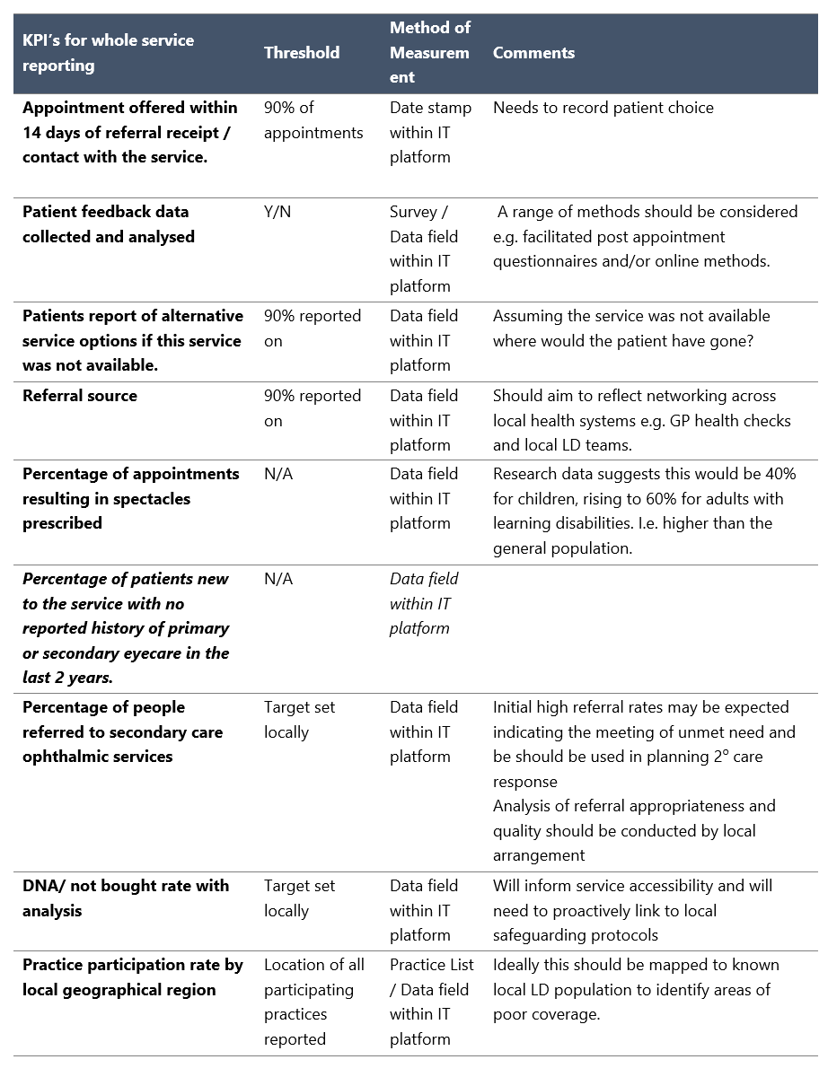
A comprehensive minimum clinical data set (MDS) will be agreed locally prior to service implementation.
Collecting case studies
A patient and/or supporter experience questionnaire and its administration should form part of the service; LOCSU will make available templates to facilitate this. To support service promotion, it is important to gather positive stories about how the service has helped people with learning disabilities. This will help with evaluating the service in the future. The sorts of significant interventions described above will possibly have life changing consequences for the person and so make some of the best-case studies.

Fees
A fee of (insert) for will apply. This fee includes all elements of the managed service:
- The professional fee for the clinical service
- All administration costs
- Reporting and attendance at contract monitoring meetings
- The use of the IT platform

Implementation
Full implementation will take up to 3 months from the date that [name] CCG commissions the service.
During this mobilisation period, the company will:
- Support practitioner accreditation and training
- Work with local GPs, specialist hospital teams, leads within the special schools and the CCG lead managers for eye care and learning disability care to finalise the pathway locally. This will specifically include establishing a local referral pathway from GPs into the service as part of Annual Health Check and a clear specialist onward referral pathway to an ophthalmology service with a specialism in assessing and treating people with learning disabilities/complex needs.
- Develop a communications plan and materials for all potential referrers set out within the pathway
- Agree all policies and procedures
- Tailor the IT software to ensure it meets all CCG requirements (if applicable) and develop the monitoring database and audit materials

Appendix 1 – Optical practices

[Name] CCG has [insert number of practices] optical practices currently providing General Ophthalmic Services.
[Primary Eye Care Company] has surveyed these practices and has received Expressions of Interest from [insert number] regarding becoming learning disability eye care pathway providers.
List practices
All of the practitioners involved would undergo the accreditation programme as previously described.

Appendix 2 – Service Pathway
Enhanced eye care for People with Learning Disability

A sight-testing service for any child, young person or adult who is recognised by their GP as having a learning disability e.g. who has been registered on a local learning disability register
Person signposted / referred into service
GP during annual health check, learning disability or special educational needs services, a carer or advocate, optometrist, optician or OMP. The patient may be recalled or self-refer.
The person may also be or be transferred from a service in special school or Hospital eye service.

Preparation and information gathering
“Telling the optometrist about me”
Consider the need for a Functional Vision Assessment
Consider arranging a pre-visit supported by the person’s chosen supporter
Domiciliary appointment offered if appropriate

Sight test Appointment
May include extended times and multiple visits

Referral to other service for management
E.g. MECs or GP service
Referral to HES
+/- Advice and guidance
Pathology or
Sight test not possible under service, referral to specialist multi-disciplinary team at HES
(Contact HES team before making a referral)
Dispense spectacles
Registered Optometrist / Dispensing Optician
“Wearing glasses”
“Getting used to glasses”

Reporting and Recall
Report provided to the patient and copied to their carer and GP, to include advice to record relevant detail in EHCP, Health Action Plan, Social Care Support Plan
“Feedback from the optometrist about my eye test”
Recall indicated
Service experience questionnaire provided

Further advice
May need ECLO, certification, registration, low vision aid services and sensory service support

Appendix 3 – Governance: Quality in Optometry

Many aspects of clinical governance in optometric practice are enshrined in legislation or regulation as well as in the College of Optometrists' Guidance for Professional Practice, the Association of British Dispensing Opticians Advice and Guidelines and in other guidance documents.

GOS contract compliance checklist. This level is used by NHS England Area Teams for the purposes of checking and monitoring GOS contract compliance. Contractors are required to complete and submit a Level 1 report every three years, together with an action plan for rectifying any non-compliant issues. Practices that flag as outliers on this and other criteria, together with a small random selection of others, may receive compliance visits.

NHS Standard Contract compliance checklists are clinical governance tools specifically designed for extended primary care and community services (previously enhanced services).

There are audits toolkits available such as record keeping and infection control.

Practitioner and non-clinical staff checklists summarise the knowledge that a contractor will require of employees and practitioners as a part of complying with the GOS contract.
Quality in Optometry NHS Standard Contract compliance checklists covers clinical governance with a particular emphasis on community services. The funding for this level of clinical governance is included as part of our proposal.

Appendix 4 - Equipment

All optical practices are expected to have appropriate equipment, which will be maintained and fit for purpose. An example practice equipment list, beyond that typically used within GOS, is provided below:

Cardiff cards (acuity)
Kays crowded logMAR book set, Kays 3-meter book set, Keeler acuity Cards, Keeler crowded LogMAR 3m test or iPad with Kays app, Peekaboo
Bradford Visual Function Box
Contrast sensitivity test: e.g. Cardiff contrast test
Accommodative function test: e.g. Ulster-Cardiff accommodation CUBE
Colour Vision Testing Made Easy
10 Base prism on stick
20 base prism on stick
Large aperture trial lens set/ paddles
Fixation sticks, toys, visual attention grabbers
Means of binocular indirect ophthalmoscopy
Pen torches
Placido disc
Tonometer (ideally iCare)
Titmus fly stereo test
Lang I and II stereo tests
Occluding glasses large/small x2
Ophthalmic Drugs - Cyclopentolate 1%, Fluorescein Sodium minims
Dispensing spares box, including straps/headbands
Files and locknut wrenches
Appropriate rules to measure frames and faces. Fairbanks Facial, City 2000 or ABDO rule plus transparent mono rule
Frame heater
Appropriate range of pliers and side cutters

Mencap (2020) Research and Statistics ‘How common is a learning disability’. www.mencap.org.uk
NHS England (2019). The Long Term Plan. https://www.longtermplan.nhs.uk/
Public Health England (2011). The Estimated Prevalence of Visual Impairment among People with Learning Disabilities in the UK. Eric Emerson and Janet Robertson. https://www.seeability.org/reports-research
For example, see Learning disabilities eye care pathway – Tri-Borough London pilot (2015). https://www.seeability.org/reports-research
Public Health England (2020). Eye care and people with learning disabilities. https://www.gov.uk/government/publications/eye-care-and-people-with-learning-disabilities
General Optical Council (2016). Standards of practice for optometrists and dispensing opticians. https://standards.optical.org/areas/practice/
Department of Health and Social Care (2019). Learning disability and autism training for health and care staff. https://www.gov.uk/government/consultations/learning-disability-and-autism-training-for-health-and-care-staff
https://wopec.co.uk/
See https://www.qualityinoptometry.co.uk/

